# Picture 1

American International University-Bangladesh

**Final Term Report**

**Project Title:** Tour Guide Management System

**Course Name:** ADVANCE DATABASE MANAGEMENT SYSTEM

**Course Teacher:** Rezwan Ahmed

**Semester: Summer** 21-22

|  |  |  |
| --- | --- | --- |
| Name | ID | Section |
| Anik Sen | **20-42138-1** | **C** |
| Abdullah Yousuf Noman | **20-42130-1** | **C** |
| Musfiqur Rahman | **20-42558-1** | **C** |
| Ananna Rashid Kumkum | **20-43589-1** | **C** |

***Table of Contents***

Admin Panel 3

Interfaces 4

Searching Queries 6

Table with Sequence 9

View 12

Procedures and Functions(Using Packages and Exceptions Handling) 14

Triggers 18

* **We created the admin pannel page where an admin can log in to the system, if he doesn’t have an account he can easily create a new account from sign up option.**

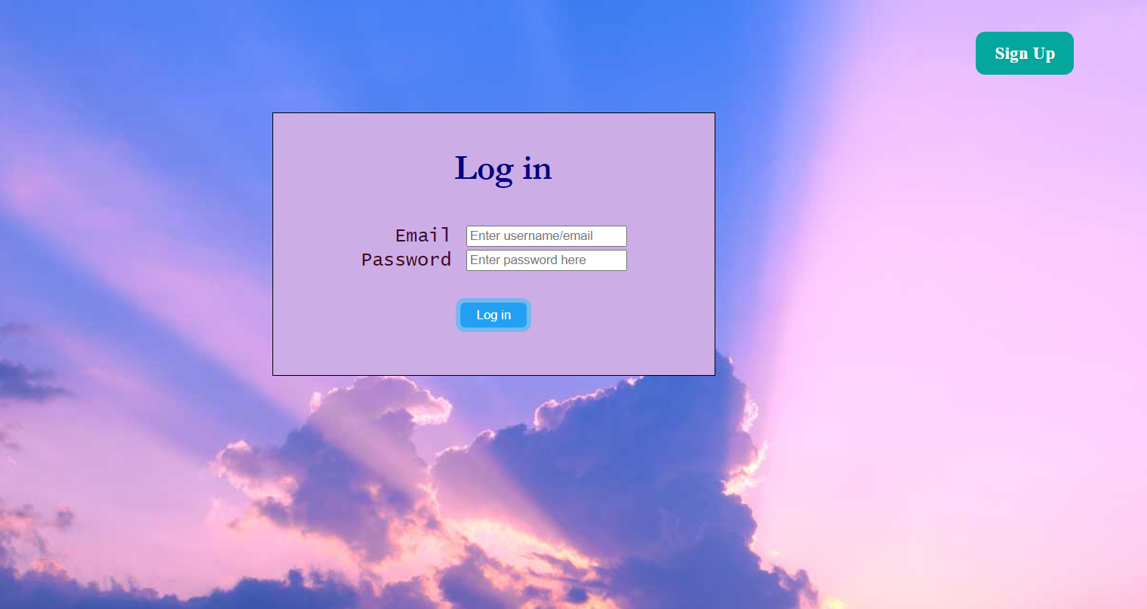

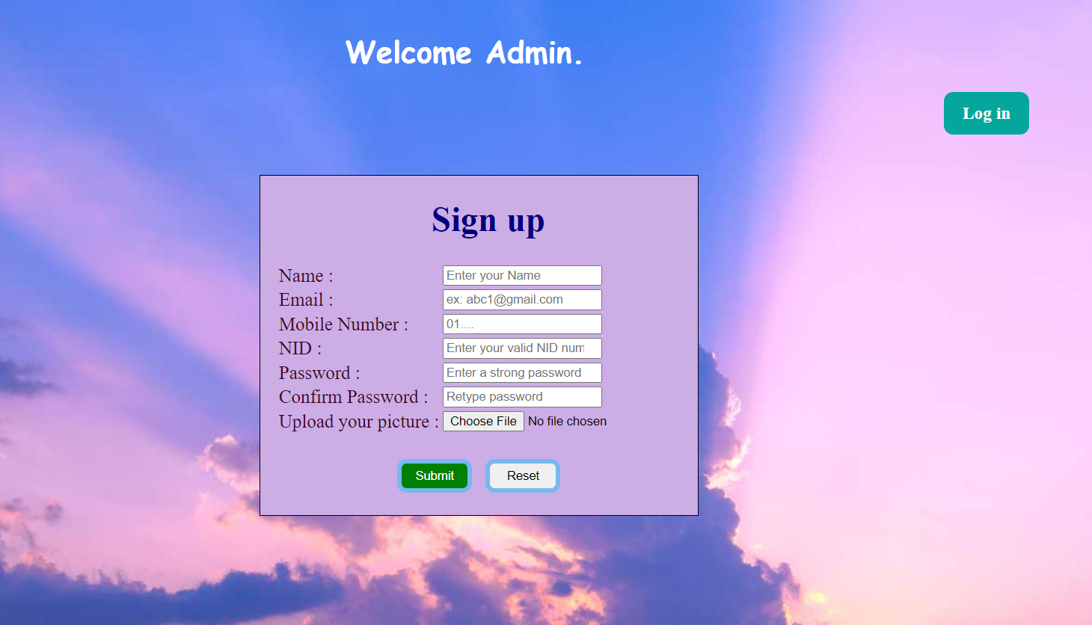

* Admin’s database where data stored after sign up.

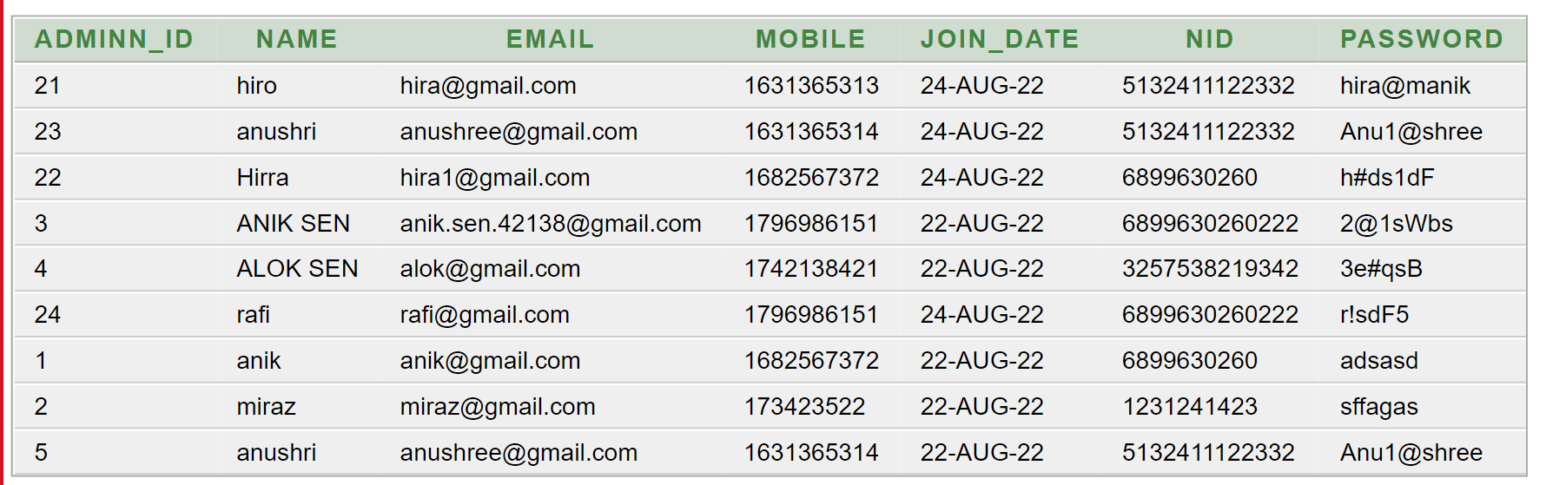

* **Interfaces to communicate with database.**

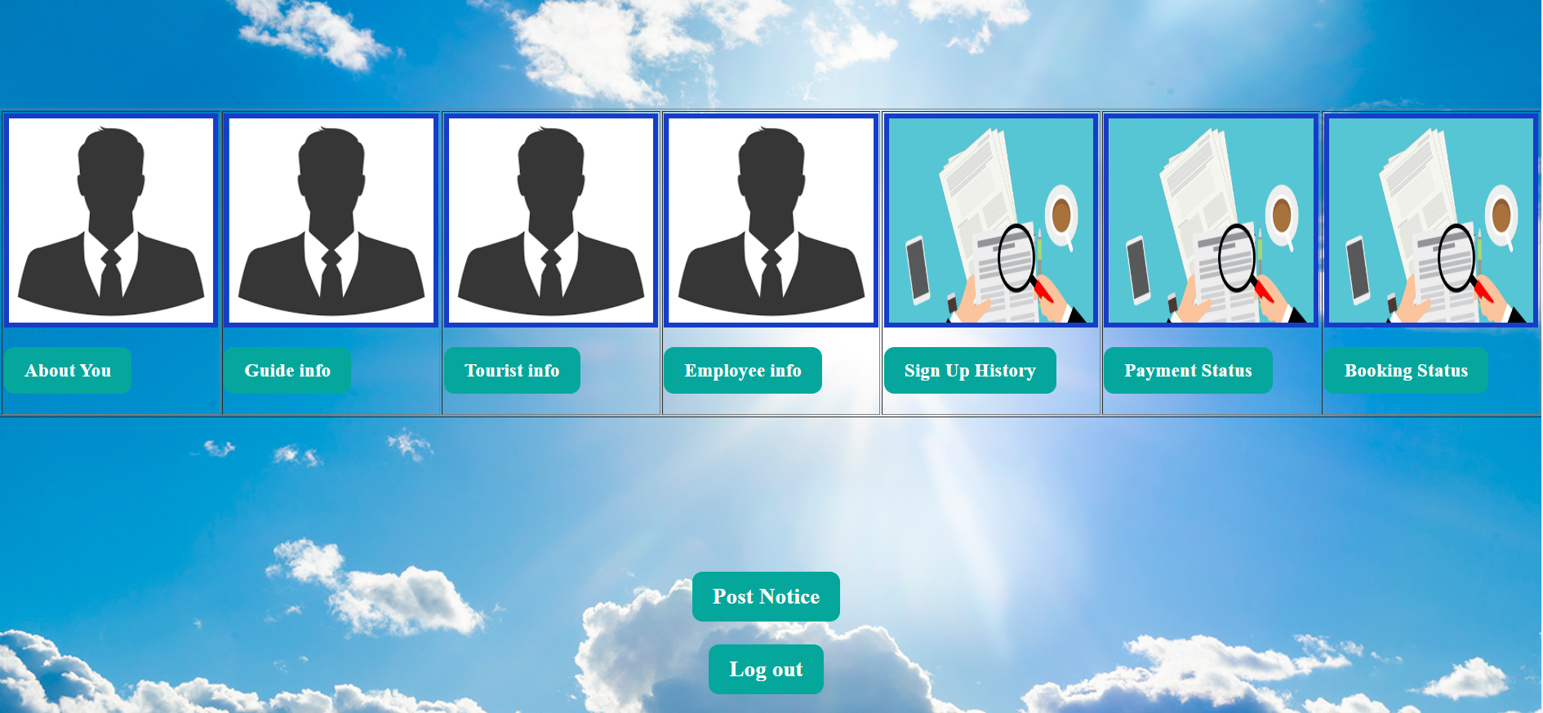

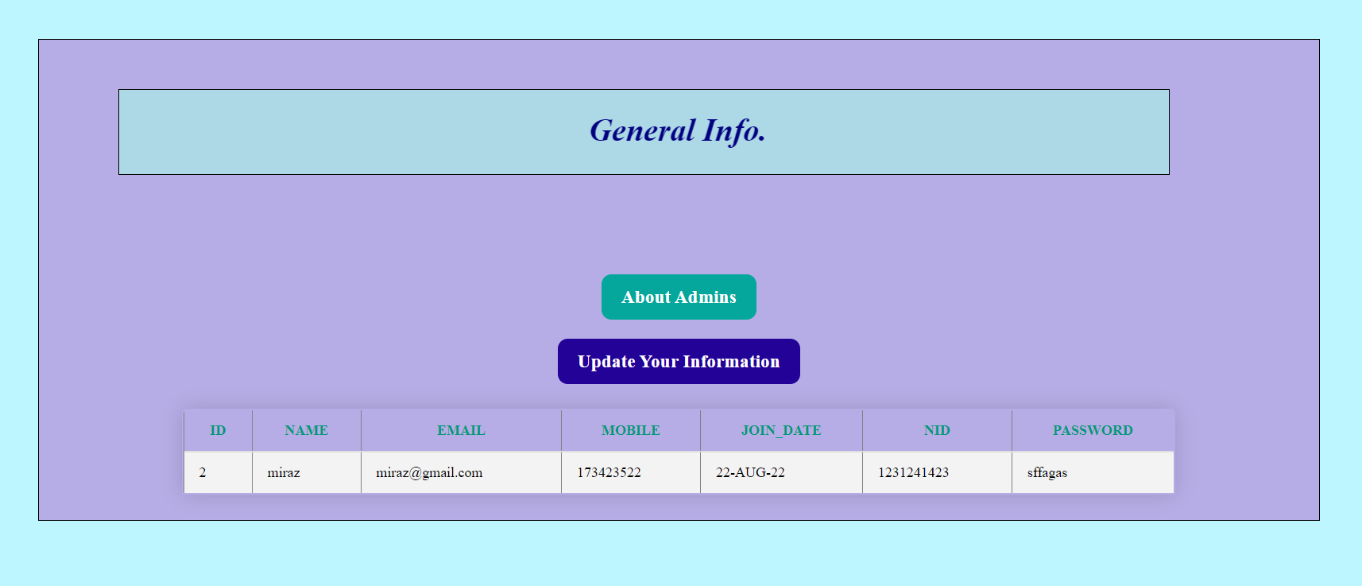

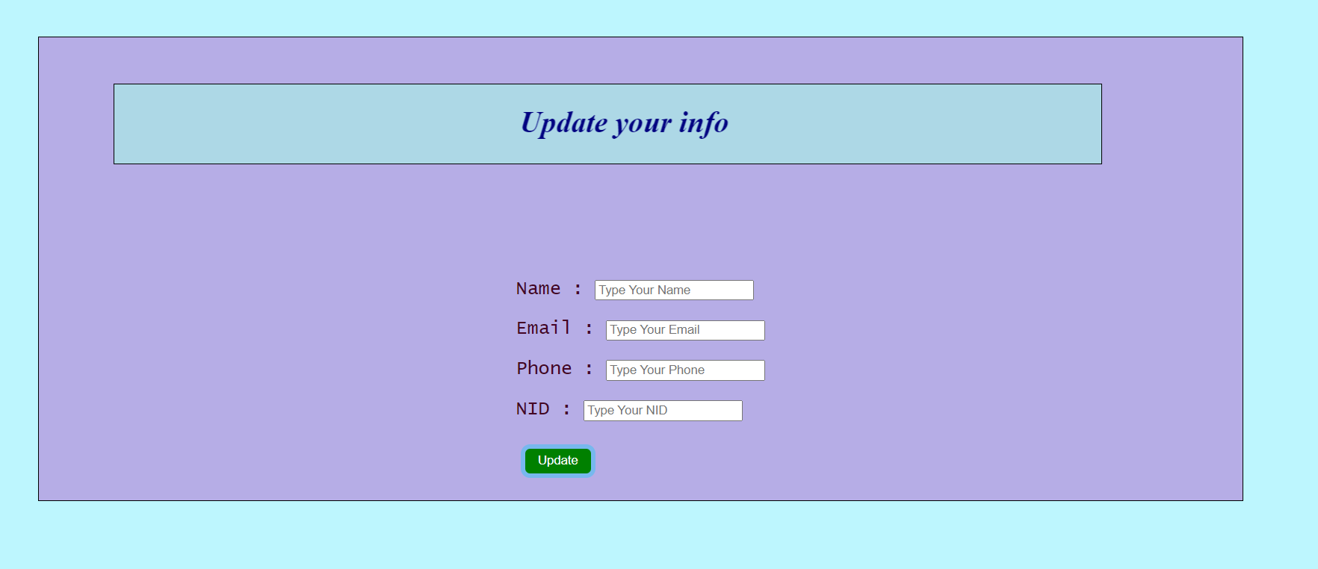

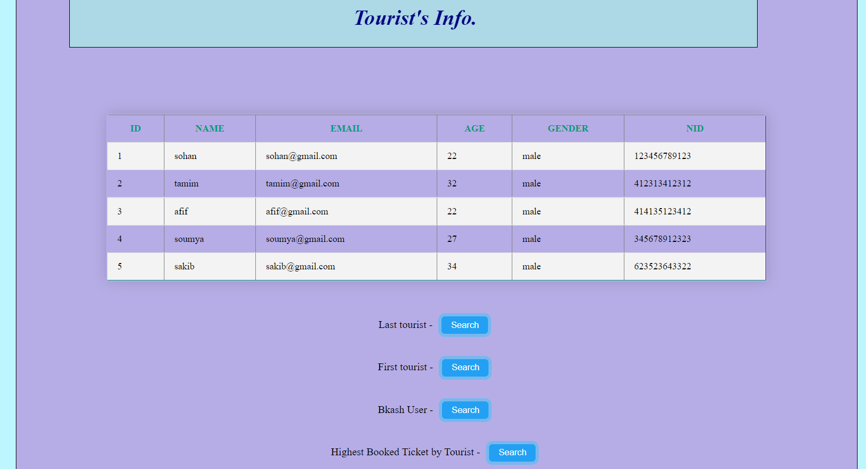

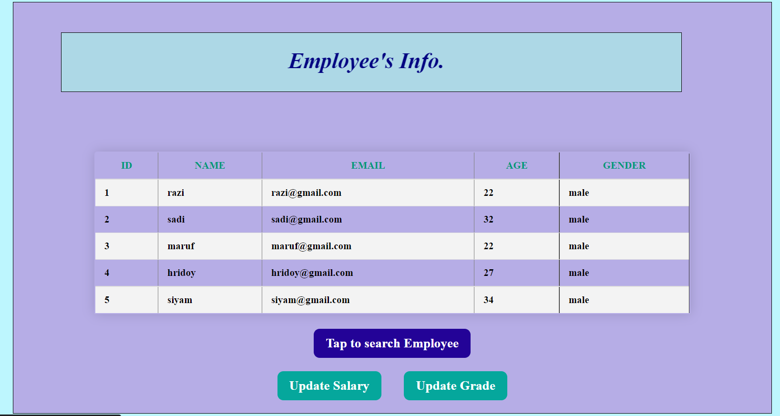

* **Different type of searching and advance searching. Some of them are attached from system.**
* **Display the payment method and amount considering the highest quantity of ticket.**

select pay_type, pay_amount from payment where quantity = (select max(quantity) from payment)

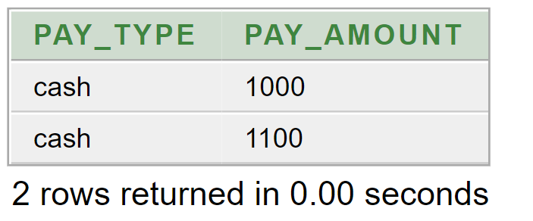

* **Display the employee details who joined after 'maruf' and age is more than 28**

select e.e_id, e.name, e.email, e.age, e.gender, e.nid, e.joindate from emp e,emp m where m.name='maruf' and m.e_id<e.e_id and e.age>28;

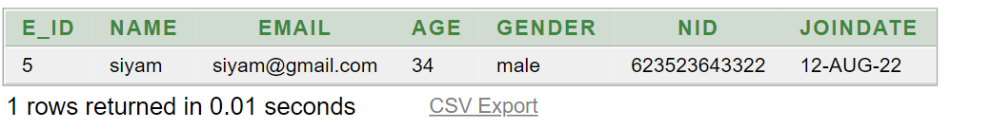

* **Display all the admins info order by admin id.**

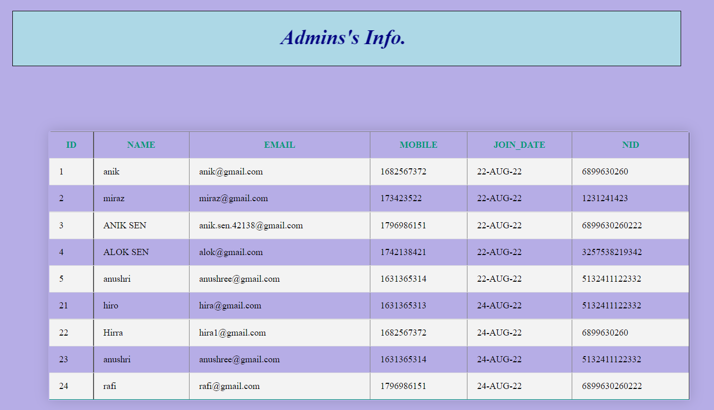

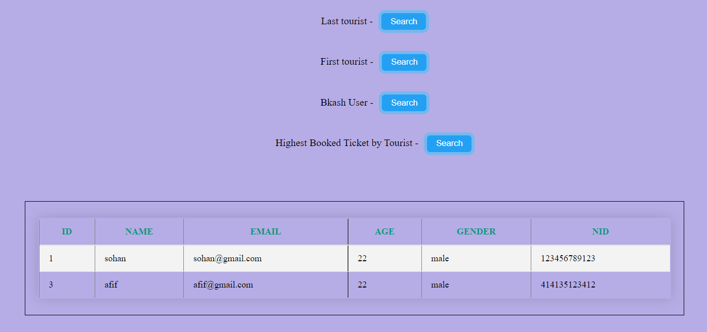

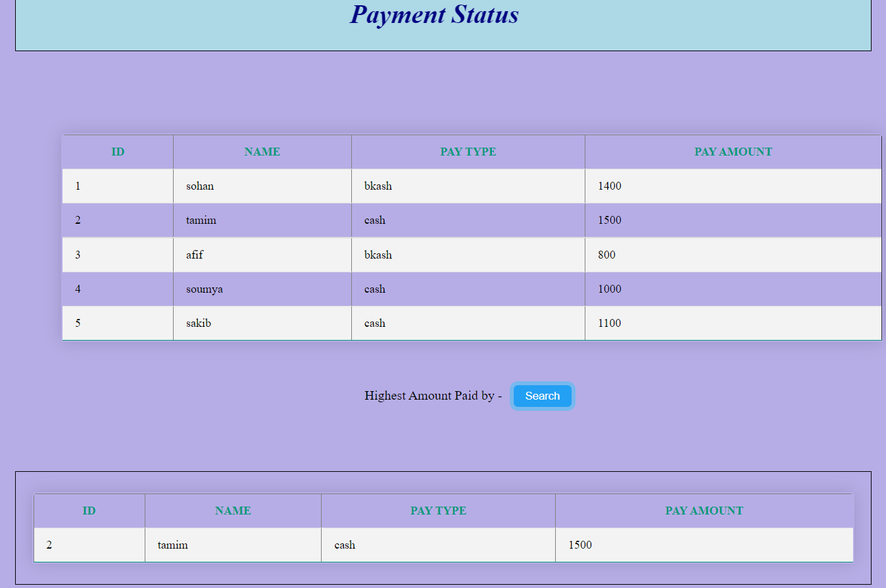

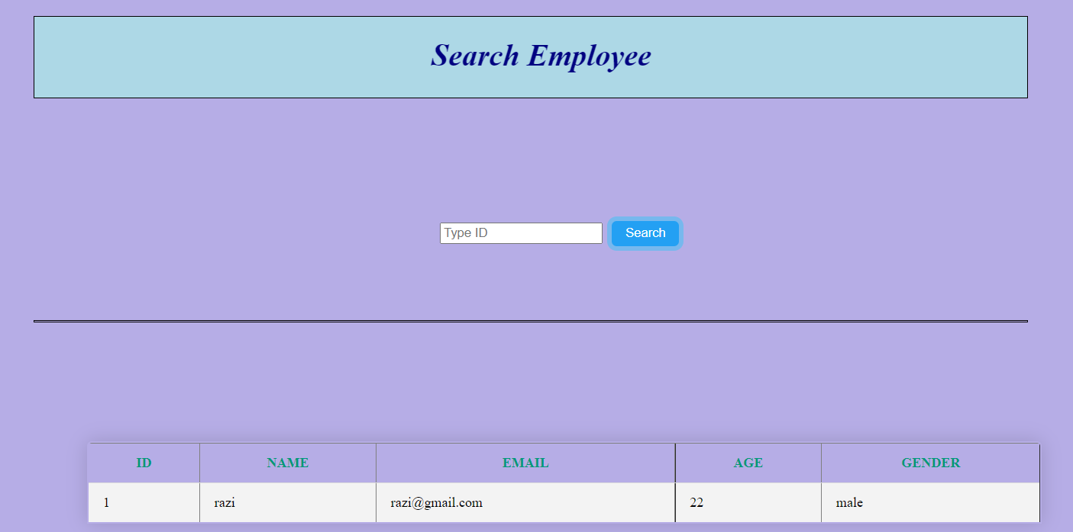

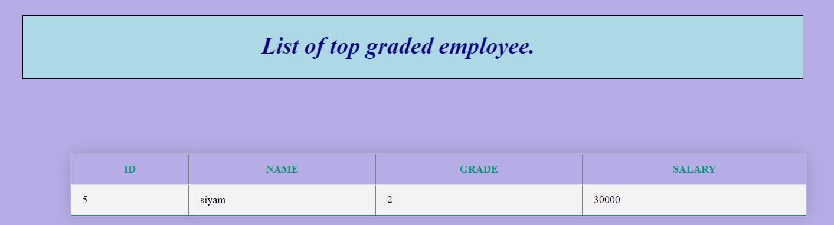

* **Tables using sequence to maintain primary key**

**Table : adminn**

create table adminn (

adminn_id number(30),

name varchar(30) not null,

email varchar(30) not null,

mobile number(11) not null,

join_date date not null,

nid number(13) not null,

password varchar(20) not null,

primary key (adminn_id));

CREATE SEQUENCE adminn_id

START WITH 1

INCREMENT BY 1

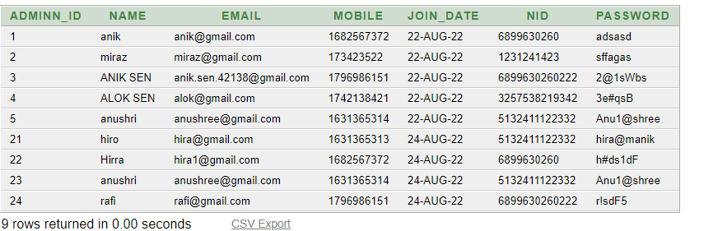

**Table : tourist_info**

create table tourist_info(

t_id number(20) not null,

name VARCHAR(50) not null,

email varchar(20) not null,

age number(30) not null,

gender varchar(20),

nid number(20) not null,

password varchar(8) not null,

primary key (t_id));

CREATE SEQUENCE t_id

START WITH 1

INCREMENT BY 1

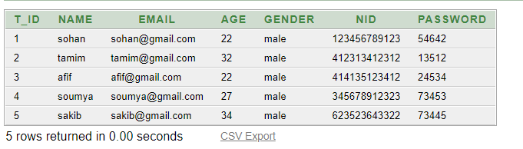

**Table : emp**

create table emp(

e_id number(20) not null,

name VARCHAR(50) not null,

email varchar(20) not null,

age number(30) not null,

gender varchar(20),

nid number(20) not null,

password varchar(8) not null,

joindate date not null,

primary key (e_id));

CREATE SEQUENCE e_id

START WITH 1

INCREMENT BY 1

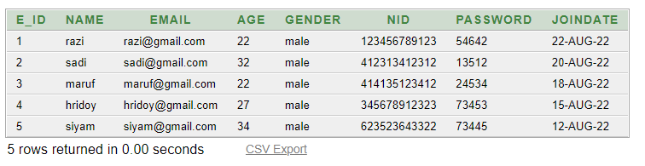

**Table : payment**

create table payment(

pay_id number(20) not null,

quantity number(20) not null,

pay_type varchar(20) not null,

pay_amount number(20) not null,

t_id number(20) not null,

primary key (pay_id),

FOREIGN KEY (t_id) REFERENCES tourist(t_id)

);

CREATE SEQUENCE pay_id

START WITH 1

INCREMENT BY 1

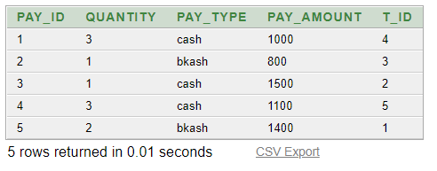

**Table : booking**

create table booking(

book_id number(20) not null,

book_type VARCHAR(20) not null,

pay_id number(20) not null,

primary key (book_id),

FOREIGN KEY (pay_id) REFERENCES payment(pay_id)

);

CREATE SEQUENCE book_id

START WITH 1

INCREMENT BY 1

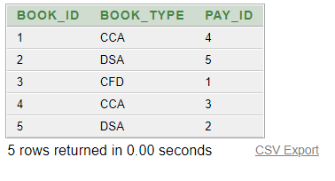

* **View**
* CREATE OR REPLACE VIEW emp_detail_view AS

SELECT e_id, NAME, email, age, gender

FROM emp

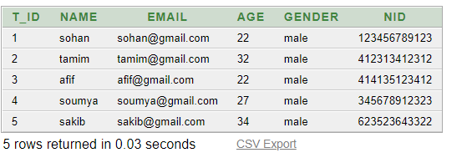

* CREATE or replace VIEW Hpaid_emp_view AS

select e.e_id, e.name, d.grade, g.salary

from sal_detail d, salgrade g, emp e

where d.e_id = e.e_id and d.grade = g.grade and g.grade<=2

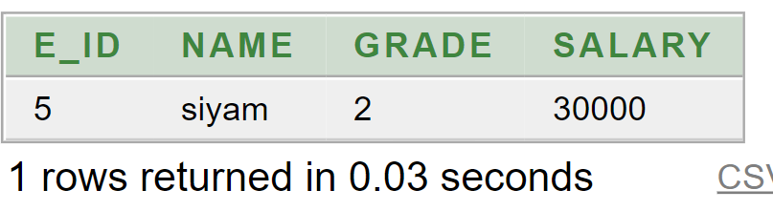

* CREATE or Replace VIEW payment_by_user AS

SELECT t.t_id, t.NAME, p.pay_type, p.pay_amount

FROM tourist_info t, payment p where t.t_id = p.t_id order by t.t_id

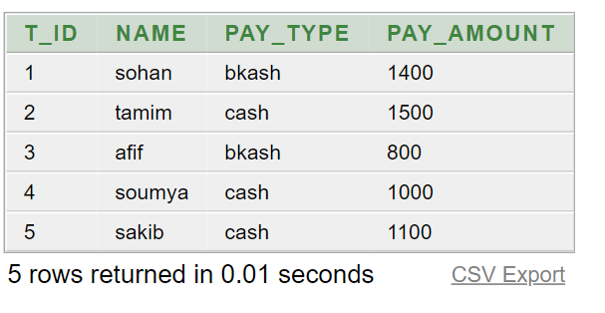

* CREATE or Replace VIEW booked_by_user AS

SELECT t.t_id, t.name, p.pay_id, b.book_type

FROM tourist_info t, payment p, booking b where t.t_id = p.t_id and p.pay_id = b.pay_id order by t.t_id

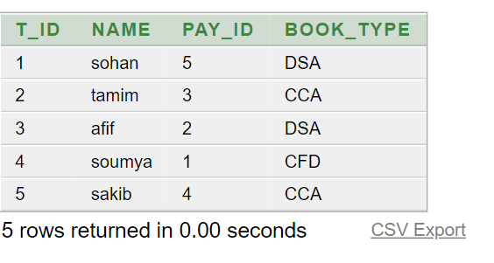

* CREATE or replace VIEW admin_detail_view AS

SELECT adminn_id, NAME, email, mobile, join_date, nid

FROM adminn

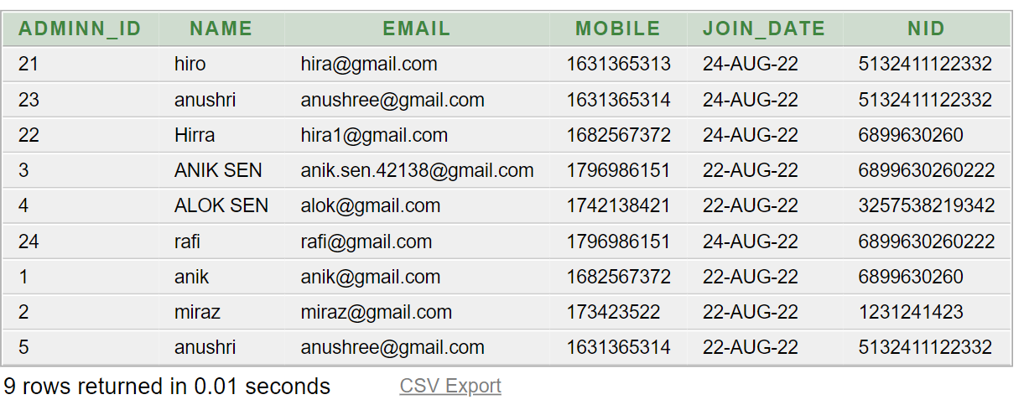

* **Procedures and Functions (Using Package and Exception handling)**
* This package is used for admin’s registration and update admin’s info. There are two procedures under this package. We use some exception handling approach here

create or replace package pack_admin_add_update

as

procedure proc_add_admin(aname adminn.name%type, mail adminn.email%type, phone adminn.mobile%type, nidd adminn.nid%type, pass adminn.password%type);

procedure proc_update_admin(aname adminn.name%type, mail adminn.email%type, phone adminn.mobile%type, nidd adminn.nid%type, pass adminn.password%type);

end pack_admin_add_update;

create or replace package body pack_admin_add_update

is

procedure proc_add_admin(aname adminn.name%type, mail adminn.email%type, phone adminn.mobile%type, nidd adminn.nid%type, pass adminn.password%type)

is

begin

insert into adminn (ADMINN_ID,NAME,EMAIL,MOBILE,JOIN_DATE,NID,PASSWORD) values (adminn_id.nextval, aname, mail, phone, sysdate, nidd, pass);

end proc_add_admin;

procedure proc_update_admin(aname adminn.name%type, mail adminn.email%type, phone adminn.mobile%type, nidd adminn.nid%type, pass adminn.password%type)

is

begin

update adminn set name = aname, email = mail, mobile =phone, nid=nidd where password = pass;

end proc_update_admin;

end pack_admin_add_update;

* This package is used for employee’s grade update, delete and insert purpose. There are three procedures and two functions under this package. We use some exception handling approach here

create or replace package emp_grade

as

procedure emp_grade_up(id emp.e_id%type, grd sal_detail.grade%type);

procedure emp_grade_delete(id emp.e_id%type);

procedure emp_grade_insert(id emp.e_id%type, grd sal_detail.grade%type);

end emp_grade;

create or replace package body emp_grade

is

function VALID_EMPNO(id emp.e_id%type)

return boolean

is

chk emp.e_id%type;

begin

select e_id into chk from emp where id = e_id;

return true;

exception

when no_data_found then

return false;

end VALID_EMPNO;

function VALID_GRADE(grd salgrade.grade%type)

return boolean

is

chk salgrade.grade%type;

begin

select grade into chk from salgrade where grade = grd;

return true;

exception

when no_data_found then

return false;

end VALID_GRADE;

procedure emp_grade_up(id emp.e_id%type, grd sal_detail.grade%type)

is

begin

if (VALID_EMPNO(id)) then

if (VALID_GRADE(grd)) then

update sal_detail set grade=grd where e_id=id;

dbms_output.put_line('Grade Updated');

else

dbms_output.put_line('Invalid Grade');

end if;

else

dbms_output.put_line('Employee ID does not exist');

end if;

end emp_grade_up;

procedure emp_grade_delete(id emp.e_id%type)

is

begin

if (VALID_EMPNO(id)) then

delete from sal_detail where e_id=id;

else

dbms_output.put_line('Employee ID does not exist');

end if;

end emp_grade_delete;

procedure emp_grade_insert(id emp.e_id%type, grd sal_detail.grade%type)

is

begin

if (VALID_GRADE(grd)) then

insert into sal_detail values(id, grd);

else

dbms_output.put_line('Invalid Grade');

end if;

end emp_grade_insert;

end emp_grade;

* This package is used for employee’s salary update purpose. There is a procedure and a function under this package. We use some exception handling approach here

create package pack_sal_update

as

procedure proc_sal_update(grad salgrade.grade%type, sal salgrade.salary%type);

end pack_sal_update;

create or replace package body pack_sal_update

is

function VALID_GRADE(grad salgrade.grade%type)

return boolean

is

chk salgrade.grade%type;

begin

select grade into chk from salgrade where grade = grad;

return true;

exception

when no_data_found then

return false;

end VALID_GRADE;

procedure proc_sal_update(grad salgrade.grade%type, sal salgrade.salary%type)

is

begin

if (VALID_GRADE(grad)) then

update salgrade set salary = sal where grade = grad;

dbms_output.put_line('Salary Updated.');

else

dbms_output.put_line('This Grade does not exist');

end if;

end proc_sal_update;

end pack_sal_update;

* This package is used for search some tourist information. There is a procedure named proc_bkash_user . We use some exception handling approach here

create package pack_under_tourist

as

procedure proc_bkash_user(id OUT tourist_info.t_id%type, tname OUT tourist_info.name%type, temail OUT tourist_info.email%type, tage OUT tourist_info.age%type, tgender OUT tourist_info.gender%type, tnid OUT tourist_info.nid%type);

end pack_under_tourist;

create or replace package body pack_under_tourist

is

procedure proc_bkash_user(id OUT tourist_info.t_id%type, tname OUT tourist_info.name%type, temail OUT tourist_info.email%type, tage OUT tourist_info.age%type, tgender OUT tourist_info.gender%type, tnid OUT tourist_info.nid%type)

is

cursor c1

is

select t_id, name, email, age, gender, nid from tourist_info where t_id in (select t_id from payment where pay_type = 'bkash');

i number(25);

begin

for i in c1 loop

id := i.t_id;

tname := i.name;

temail := i.email;

tage := i.age;

tgender := i.gender;

tnid := i.nid;

dbms_output.put_line(id||' '|| tname ||' '|| temail ||' '|| tage ||' '|| tgender||' '|| tnid);

end loop;

end proc_bkash_user;

end pack_under_tourist;

declare

id tourist_info.t_id%type;

tname tourist_info.name%type;

temail tourist_info.email%type;

tage tourist_info.age%type;

tgender tourist_info.gender%type;

tnid tourist_info.nid%type;

begin

pack_under_tourist.proc_bkash_user(id, tname , temail , tage , tgender, tnid);

end;

* **Triggers**
* This trigger is used to keep the log of admin registration.
* create table admin_reg_log ( user_name varchar(20), opt_name varchar(20), opt_date date);

create or replace trigger admin_reg_log

after insert on adminn

declare

opt varchar(30);

begin

opt := 'sign up';

insert into admin_reg_log values(user,opt,sysdate);

end;

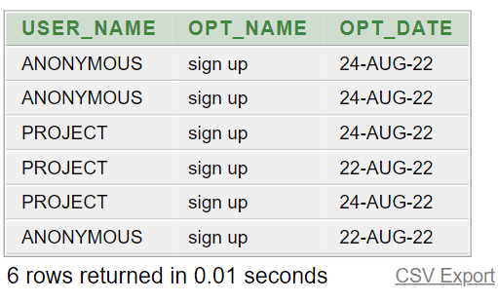

* This trigger is used to keep secure the employee registration process.
* create or replace trigger emp_reg_secure

before insert on emp

declare

begin

if to_char(sysdate,'HH24') not between '8' and '17' or to_char(sysdate,'DAY') in('FRIDAY', 'SATURDAY') then

raise_application_error(-20202, 'Please come in regular working working hour');

END IF;

End;

* This trigger is used to keep the log of employee registration.
* create table emp_reg_log ( user_name varchar(20), opt_name varchar(20), opt_date date);

create or replace trigger emp_reg_log

after insert on emp

declare

opt varchar(30);

begin

opt := 'sign up';

insert into emp_reg_log values(user,opt,sysdate);

end;



* This trigger is used to keep the log of employee’s grade update.
* create table emp_grade_uplog ( e_id number(20), old_grade number(20), up_grade number(20), up_date date);

create or replace trigger emp_grade_up

after update of grade on sal_detail

for each row

begin

insert into emp_grade_uplog values (:old.e_id, :old.grade, :new.grade, sysdate);

end;

* create or replace trigger sal_alart

before update on salgrade

for each row

begin

if :new.salary < :old.salary then

raise_application_error(-20202, 'Warning: Updated salary must be greater then previous salary.');

END IF;

End;

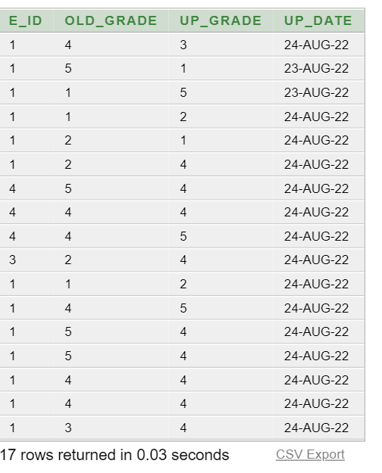

* This trigger is used to keep the log of employee’s salary update.
* create table emp_sal_uplog ( grade number(20), old_salary number(20), updated_salary number(20), update_date date);

create or replace trigger emp_sal_up

after update of SALARY on salgrade

for each row

begin

insert into emp_sal_uplog values (:old.grade, :old.salary, :new.salary, sysdate);

end;

